Module 4 — Benchmarking for Better Farming
The best farming knowledge in the district may already exist — it may be a neighbouring farmer who is getting good results in the same soil and climate.

1. Learning Objectives
- Understand what benchmarking is and why it is useful for farming.
- Learn how the GramIQ Farm Profit Management tool does benchmarking.
- Understand which practices can be learned from benchmark farmers and applied on your own farm.

2. Introduction
In Modules 1, 2 and 3 we saw how important it is to have your own records in order to understand your own production cost, opportunity cost and economic optimum. But if we think beyond this, one question remains — what exactly are the farmers who perform better than us doing differently?
Benchmarking tries to answer this very question. The best farming knowledge in the district may already exist — it may be a neighbouring farmer who is getting good results in the same soil and climate. What is needed is to identify such farmers and carry their practices to others.

4.1 What is benchmarking?
Benchmarking is the process of comparing your own farming with the farm-economic results and practices of other successful farmers in the same soil, climate and geographic conditions, in order to identify and learn good practices.
Even with the same soil, the same climate and the same geographic conditions, the results of two farmers — production cost, output and profit — can be very different. If this difference is understood, it becomes possible to obtain higher output and higher profit at lower cost.
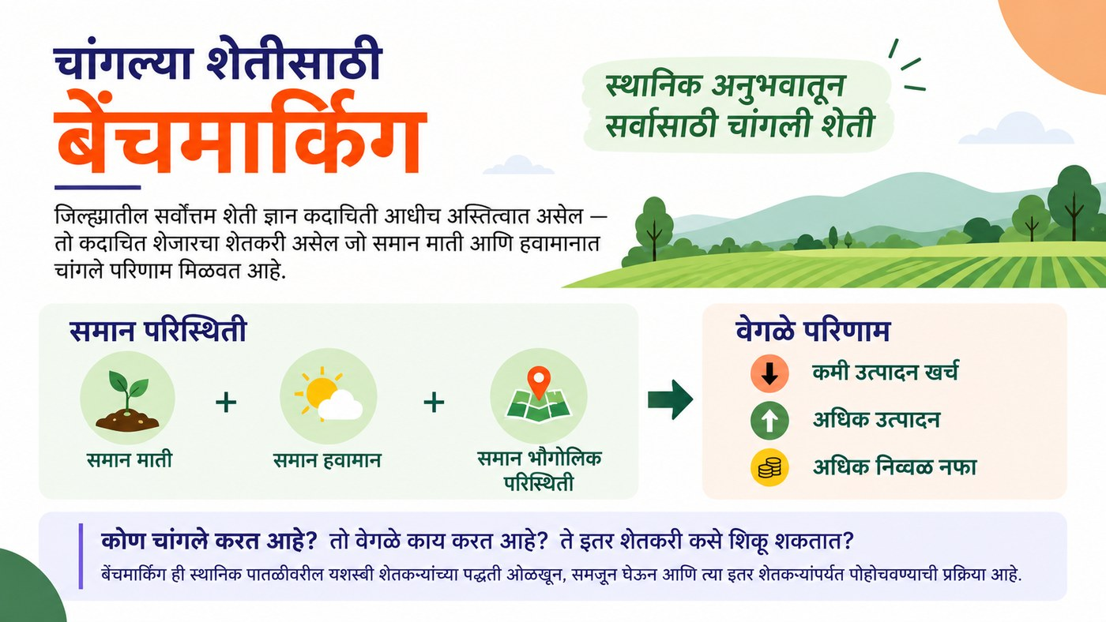
Figure 4.1 — What is benchmarking? Same conditions, different results

4.2 How does benchmarking work?
Farmers who regularly use the GramIQ Farm Profit Management tool record their production cost (A2), output, selling price and net profit. When the data of 1,000 farmers in a district is analysed, GramIQ can identify farmers who, in the same soil, climate and geographic conditions, are achieving lower production cost, higher output and higher net profit.
For example, look at the table below — how much better a benchmark farmer’s results can be compared with the district average:
Table 4.1 — District average versus benchmark farmer
Indicator | District average | Benchmark farmer
A2 production cost | ₹24,000/acre | ₹19,000/acre
Output | 8.0 quintals/acre | 10.0 quintals/acre
Net profit | ₹16,000/acre | ₹31,000/acre

These high-performing farmers become local benchmark farmers for their geographic area. After that, GramIQ can study what these farmers are doing differently — such as fertiliser management, seed rate, timely sowing, use of pesticides, irrigation and other farming practices.
GramIQ’s method is this: regular farm profit records → A2 cost + output + net profit → identification of local benchmark farmers → study of their farming practices → comparison with other farmers → sharing proven local practices → lower cost + higher output + higher profit.
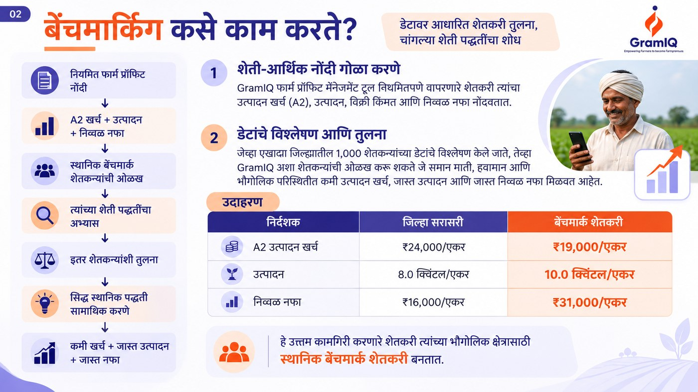
Figure 4.2 — How benchmarking works (GramIQ’s method)

4.3 What can be learned from benchmark farmers?
It is not enough to look only at the results — it is important to understand the practices behind them. Benchmark farmers are usually different and better in the following respects:
- Fertiliser management — the right quantity, the right time
- Seed rate — how much seed, which method
- Timely sowing — the right time for sowing
- Use of pesticides — the right choice, use at the right time
- Irrigation — efficient use of water
- Other farming practices — the best practices according to local conditions
By comparing these practices with other farmers in the same area, practices linked to lower cost, higher output and higher profit can be identified. Regular farm-economic records create precisely the data that is necessary to identify, understand and repeat farming practices that perform well.
In the end there is only one goal — as Sant Tukaram Maharaj says, “Let us help one another, and together walk the good path.” The best farming knowledge may already exist in the district — it may be a neighbouring farmer who is getting good results in the same soil and climate; what is needed is only to identify that knowledge and carry it to one another.
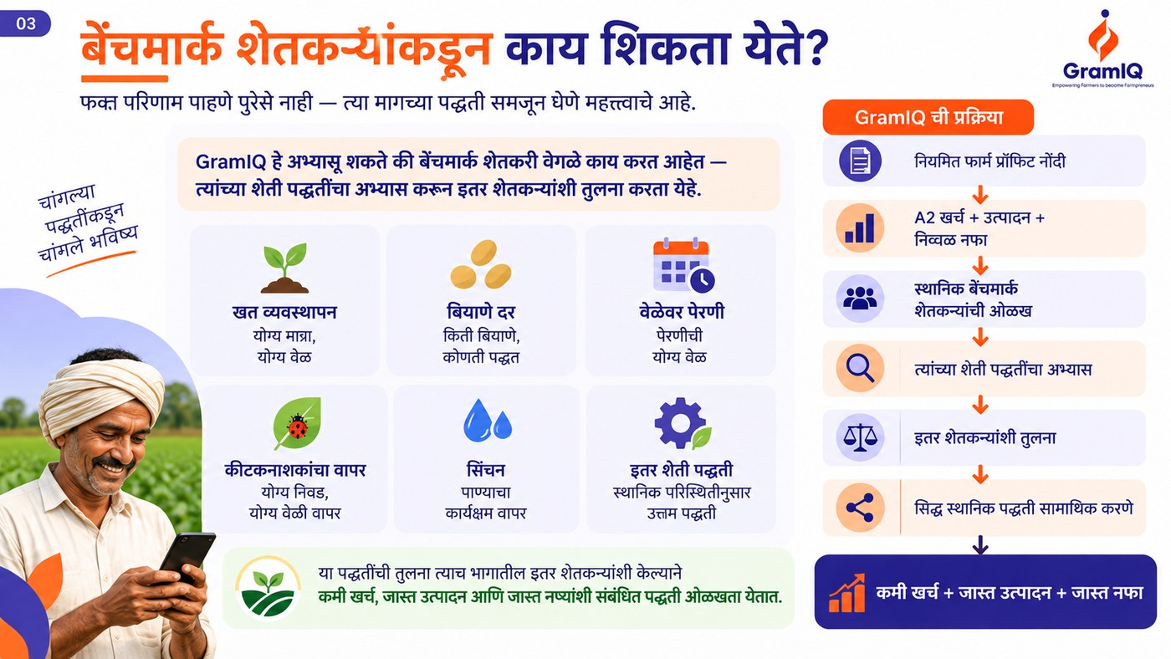
Figure 4.3 — Practices that can be learned from benchmark farmers

Key Concepts
- Benchmarking: the process of learning good practices by comparing with successful farmers in similar conditions.
- Benchmark farmer: the farmer who earns the highest profit at the lowest cost in a geographic area.
- Local farming practices: proven and successful practices regarding fertiliser, seed, sowing, irrigation, etc.

Key Takeaways
- Even with the same soil and climate, farmers’ economic results can be very different.
- Benchmarking is not possible without regular farm-economic records.
- Understanding the practices of benchmark farmers makes higher output and profit possible at lower cost.
- The best farming knowledge is often already around you, with the neighbouring farmer.

Review Questions
- What is benchmarking? Explain in your own words.
- How does GramIQ identify benchmark farmers?
- Name any three practices worth learning from benchmark farmers.

Module Summary
Benchmarking is the process of comparing your own farming with the practices of successful farmers in similar conditions. On the basis of regular farm-economic records, GramIQ identifies benchmark farmers in the district, studies their practices such as fertiliser management, seed rate, sowing time and irrigation, and carries them to other farmers — making it possible for farmers of the entire region to earn higher profit at lower cost.

